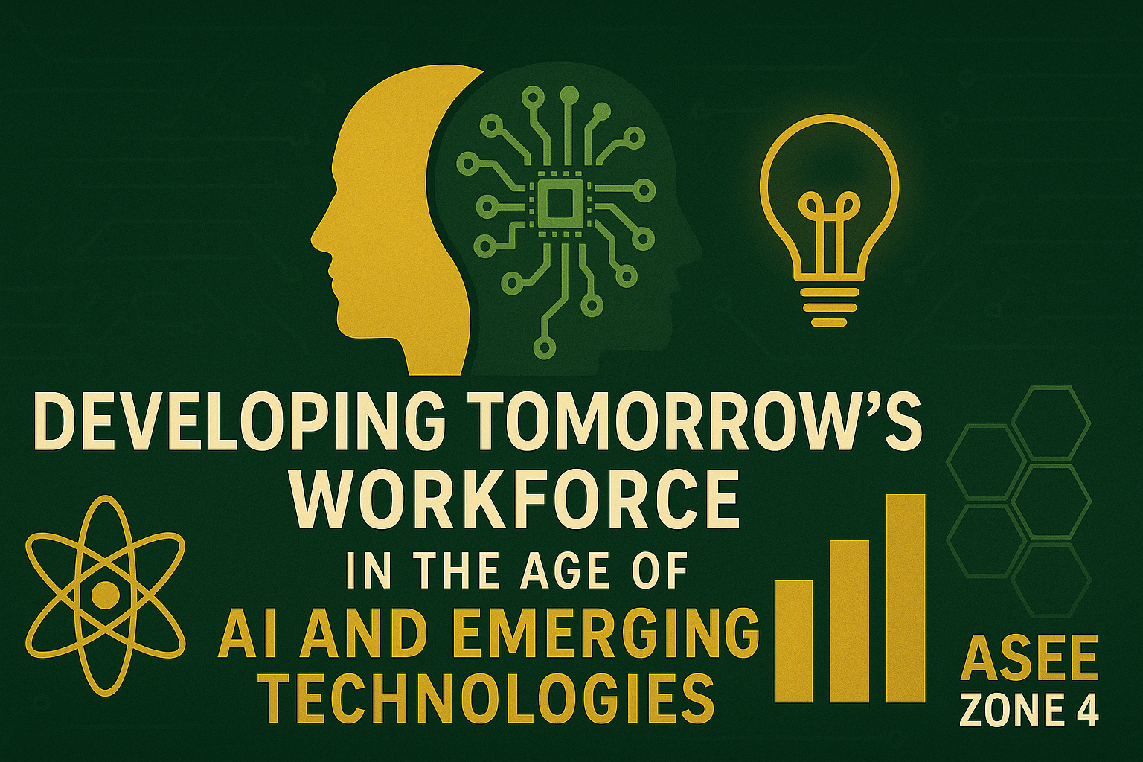

The American Society for Engineering Education (ASEE) Zone 4 encompasses Pacific Northwest, Pacific Southwest, and Rocky Mountain Sections invites the submission of abstracts for papers, presentations, posters, workshops, and lightning talks for the 2026 ASEE-Zone 4 Conference in Pomona, California on April 16-18th 2026. ASEE-Zone 4 encompasses PNW: Alaska, Idaho, Montana, Oregon, Washington, and Canada- Alberta, British Columbia, and Saskatchewan; PSW: California, Arizona, Nevada, and Hawaii; RMS: Colorado, South Dakota, Utah, and Wyoming.
This year’s theme is Developing Tomorrow’s Workforce in the Age of AI and Emerging Technology.
Engineering impacts every aspect of life, in this ever-changing technological landscape, how can educators help to prepare a workforce that is agile and ensure that we are reaching all audiences. This theme challenges us to reimagine engineering education as a catalyst for creativity, innovation, and global progress. Together, we envision a future where learners are inspired to lead transformative solutions that cross boundaries and shape a better world.
As with previous Section conferences, submissions on other topics relevant to engineering education will also be considered. A sample list of possible topics to get ideas percolating can be found below.
Rethinking Engineering Education for the Future | Harnessing AI and Emerging Technologies in the Classroom- forward thinking teaching and learning
Competency-based education models for agile engineers  Interdisciplinary approaches that integrate engineering with humanities, business, or design  Project-based and experiential learning for future-ready graduates  Curriculum redesign to respond to rapid technology shifts  Fostering creativity and innovation in traditionally technical programs  Scaling engineering education through micro-credentials and modular learning  Preparing students for jobs that don’t exist yet | AI tutors and adaptive learning platforms in engineering education  Using generative AI for design, prototyping, and problem-solving activities  Virtual and augmented reality applications in labs and coursework  Gamification and simulation tools for engineering concepts  Data-driven learning analytics to support student success  Chatbots and digital assistants for academic support  Case studies of AI-enhanced teaching practices  Balancing traditional pedagogy with AI-driven methods
Preparing Students for Emerging Industries | Ethical and responsible engineering in the age of AI- expanding access to emerging technologies
Embedding AI, robotics, quantum, or biotech topics in undergraduate curricula  Developing cross-disciplinary minors or certificates in emerging fields  Industry collaboration for hands-on projects with cutting-edge tools  Career readiness: soft skills + tech skills in a changing workforce  Teaching adaptability and resilience as core engineering skills  Role of hackathons, innovation challenges, and maker spaces  Preparing students for lifelong learning in uncertain technological futures  Credentialing systems for rapidly evolving skills (badges, stackable certificates) | Frameworks for ethical decision-making in AI-driven design  Responsible data use, privacy, and security in engineering education  Ensuring broad student access to costly or emerging technologies  Equity of opportunity in AI-enhanced classrooms (urban, rural, global contexts)  Addressing bias in AI tools and its impact on engineering solutions  Open-source and low-cost platforms to democratize technology use  Teaching students to consider social, cultural, and global impacts of engineering innovation  Policy, regulation, and governance in emerging technologies  Case studies of inclusive engineering education practices

Use the following link to submit abstract: https://nemo.asee.org/public/conferences/384/papers/new
Please see author’s toolkit for more information. Until final draft, type of submission should be included in the working title.

Dates to remember:
Abstract Submission Deadline: January 30, 2026
Abstract review Deadline: February 6, 2026
Draft submission Deadline: March 6, 2026
Draft reviews: March 27, 2026
Final Draft upload: April 10, 2026

